[1]

**Connected and Robotic Autonomous System**

|  |
| --- |
| A Project Report Presented to  The Faculty of the College of Engineering |
| San Jose State University In Partial Fulfillment  Of the Requirements for the Degree  **Master of Science in Computer Engineering** |

|  |
| --- |
| By |
| Gandhi, Prashant Shushilbhai |
| Makani, Vatsal |
| Parsana, Jay Sureshbhai |
| Shah, Saumil |
| May/2020 |

|  |
| --- |
| Copyright © 2020 |
| Gandhi, Prashant Shushilbhai |
| Makani, Vatsal |
| Parsana, Jay Sureshbhai |
| Shah, Saumil |
| ALL RIGHTS RESERVED |

|  |
| --- |
| **APPROVED** |
| Prof. Kaikai Liu, Project Advisor |

ABSTRACT

# Connected and Autonomous Robotic System

By Gandhi Prashant Shushilbhai, Makani Vatsal, Parsana Jay Sureshbhai, Shah Saumil

Nowadays autonomous robotic systems are the main focus of research in the tech industry. The project, connected and autonomous system, is an amalgam of embedded systems, IoT, distributed sensor networks, and deep learning applications. In this project, we aim to develop a drone that has autonomous capabilities and can track moving objects such as vehicles and people. Its application will be to capture videos or images of these moving objects autonomously. The ultrawide beacon, RTK GPS and a stereoscopic camera will be attached to the drone for tracking the object. The object is embedded with a beacon and an RTK GPS so that the drone can keep track of that object.

The low-level architecture is based on NuttX OS, with ArduPilot firmware, and Pixhawk 4 flight controller. The higher-level architecture uses Linux based systems that can support complex frameworks and computing-intensive applications such as object detection, classification, and system localization. The system makes use of a ZED stereo camera to get the depth information from the disparity map for autonomous landing and obstacle avoidance. We are making use of datasets that are relevant to train our deep learning models and avoid obstacles while in mid-air

|  |
| --- |
| **Acknowledgments** |
| The authors are deeply indebted to Professor Xiao Su for her invaluable  comments and assistance in the preparation of this study. |

1

Connected and Autonomous Robotic System

P. Gandhi, V. Makani, J. Parsana, S. Shah

*Abstract*—Nowadays autonomous robotic systems are the main focus of research in the tech industry. The project, connected and autonomous system, is an amalgam of embedded systems, IoT, distributed sensor networks, and deep learning applications. In this project, we aim to develop a drone that has autonomous capabilities and can track moving objects such as vehicles and people. Its application will be to capture videos or images of these moving objects autonomously. The ultrawide beacon, RTK GPS and a stereoscopic camera will be attached to the drone for tracking the object. The object is embedded with a beacon and an RTK GPS so that the drone can keep track of that object.

The low-level architecture is based on NuttX OS, with ArduPilot firmware, and Pixhawk 4 flight controller. The higher-level architecture uses Linux based systems that can support complex frameworks and computing-intensive applications such as object detection, classification, and system localization. The system makes use of a ZED stereo camera to get the depth information from the disparity map for autonomous landing and obstacle avoidance. We are making use of datasets that are relevant to train our deep learning models and avoid obstacles while in mid-air.

*Index Terms*—autonomous, ultrawide-band beacon, ZED stereo camera, Pixhawk 4, Ardupilot, localization, obstacle avoidance, deep learning, RTK GPS, tracking, object detection.

# INTRODUCTION

I

n the past few decades, autonomous robotics has made a fine share of advancements in the tech industry and continues to improve every day with the applications, not only restricted for industrial purposes but also making the step forward towards other applications where it is inefficient, impossible and dangerous for human intervention. This has been possible because of drastic improvements and support for the machine learning algorithms. Robotic systems are basically the amalgam of mechanical engineering, electronics engineering, and computer science. “Research by the Japan Robotics Association (JPA), the United Nations Economic Commission (UNEC), and the International Federation of Robotics (IFR), indicates that the market growth for personal robots, including those used for entertainment and educational purposes, has been tremendous and this trend may continue over the coming decades” [1]. With the advancement of AI and Machine learning, robotic systems have become autonomous. The word “connected” comes from the fact that these systems can have IoT capabilities that can send data for monitoring and storage over to the cloud. Our paper is focused more on drones and we thus restrict the discussion of the generic robotic system towards that area.

Drones are the nickname for unmanned aerial vehicles (UAV) which can be used for various domestic to critical applications. Lian Pin Koh and Serge A. Wich (2012) explains the use of “unmanned aerial vehicles for surveying and mapping forests and biodiversity for environmental and conservation applications, which include near-real-time mapping of local land cover, monitoring of illegal forest activities (e.g., logging, fires), and surveying of large animal species” [2]. The authors Author Milan Erdelj, Michał Król, EnricoNatalizio (2017) explain the importance of drones to help the rescue services to operate efficiently at an event of natural disaster [3]. Such applications make drones, one of the useful and popular robotic systems. The drones can come in various shapes and sizes and can be used for recreational applications such as “hobby purposes while being flown in a park to take photographs from unusual perspectives and angles. It can also be used for a commercial application such as business for surveillance, domestic policing, the delivery of goods and for oil, gas, and mineral exploration. Military applications would be drones that are used for a variety of purposes such as reconnaissance, surveillance, remote sensing, armed attacks and warfare” [4]. The drones can be either remote-controlled from the ground station or made autonomous with the help of programming.

For unsupervised navigation, autonomous drones require several sensors that work together to navigate and detect obstacles. In surveillance applications, autonomous drones make use of deep learning models that are useful for detecting the objects and tracking their movements. The authors Ludovic Apvrille, Tullio Tanzi and Jean-Luc Dugelay (2014) explain the use of Sparse3D and HOG Algorithm to detect objects and avoid obstacles providing the faster response [5]. However, their system requires an efficient autonomy to manage energy, fix the hardware-software configurations and use the system in critical situations [5]. This paper explains our project implementation of a “connected and autonomous drone system” to counter these problems.

In order to fix the hardware-software configuration issues, we propose a two-level architecture, where low-level architecture takes care of the sensing units to detect and avoid obstacles using proximity sensors such as ultrasonic sensors. The stereo camera setup is used to measure the distance to the objects. This is done by generating disparity between the left and right images and extracting a depth map from it. The high-level architecture is trained by complex deep learning models to track the objects to be monitored and collect the data to be sent to the cloud. In order to monitor the drone navigation at outdoor conditions, GPS modules can be used to pinpoint the exact coordinates of the drone. There is a possibility that drone needs to perform indoor navigation and GPS module would not work. To overcome such a scenario, we are using an ultrawide-band beacon (UWB) to get the exact drone location indoors. We aim to achieve autonomous capability by incorporating the Ardupilot on the PixHawk4 platform. The Ardupilot platform has really good support for drone applications with features such as data-logging, analysis, simulation tools, etc. [6]. Since it is an open-source platform, it has a huge ecosystem of sensors, communication protocols, and compatible hardware/computers [6].

# Related Works

There are many autonomous systems research going on that can be used as a reference to develop our project. For an indoor autonomous system, Zhengang Li, Yong Xiong, Lei Zhou (2017) explains the working of the indoor wheelchair performing the autonomous exploration based on inexpensive RGB camera and ROS. The authors explain that the wheelchair rotary systems are controlled by the robot operating system in the host computer and RGB camera is used for depth perception, indoor path planning and obstacle avoidance [7]. The Arduino microcontroller is then used to receive the data from the camera and ROS and accordingly sets the PWM signals for the motors controlling the navigation of the wheelchair.

Some of the airborne automated systems require navigation control based on IMU sensor units like accelerometers, magnetometer, gyroscope, etc. integrated along with location data. Jan Wendel, Oliver Meister, Christian Schlaile, Gert F. Trommer (2006) explain an integrated navigation system for an airborne robotic system that uses GPS and MEMS IMU sensors [8]. The authors propose the solutions for two scenarios: first when GPS data is available and second when GPS is lost [8]. Another replacement for GPS can be ultrasonic beacon which can be used for indoor positioning. Dongho Kang & Young-Jin Cha (2018) explains the use of ultrasonic beacon in the scenarios where GPS fails to work for a UAVs. The authors explain the application of a “deep convolutional neural network (CNN) for damage detection and a geotagging method for the localization of damage” [9]. “Localization, mapping, and path planning” are the most important algorithms used for any system to be autonomous. Localization, motion planning, and path planning plays an important role in deciding the shortest path that any autonomous system can travel in minimum time [10].

The paper [14] describes object detection and tracking for Drones such as Parrot AR drone. It uses an SSD CNN model for object detection. SSD model provides the performance of the Yolo model and accuracy of Region-based object detection models such as Fast-RCNN. A front camera takes a Real-Time image of an object and passes the image to a computer through a Wi-Fi interface. The computer computers the distance and position of the object in real-time and sends the roll, pitch, yaw and altitude values as parameters to the drone. The drone on receiving these values updates its flight information.

Another paper [15] describes object detection using Qualcomm Snapdragon processor 801. This development used PX4 Autopilot open-source software to manage the overall operation of the drone. Robot Operating System (ROS) is deployed on ARM core to provide Linux OS support of real-time object detection. The object tracking method uses a lightweight machine learning model and inertial measurement unit data, global positioning system data to calculate the relative distance between the drone the object in a Coordinate based system.

The ultrawideband beacon used in our project is to monitor the tracking of the autonomous drone that shall be used for the remote locations where GPS coordinates cannot be read from the GPS sensor. There are previous implementations of UWB beacon that was used for various applications. The authors Vincent Mai, Mina Kamel, Matthias Krebs, Andreas Schaffner, Daniel Meier, Liam Paull, and Roland Siegwart(2018) explained the use of UWB sensors integrated with the gyroscope which was used to create an estimator that accurately tracked the position, altitude, linear and angular velocities. “This estimator uses a complete dynamics model, which allows external disturbance estimation. However, it cannot track external forces” and need more strong assumptions for developing hardware and software platforms [12].

Another case study of using UWB technology was the development of a flight system based on the indoor positioning feature. The authors Zhiyuan Shi, Hanbo Li, Hezhi Lin, Lianfen Huang (2018) explains this application. The system was deployed on a Nano quadcopter and indoor navigation was achieved with the help of a UWB indoor positioning system and a flight control scripts. As the author explains, “The accuracy of the UWB indoor positioning system is 10cm which can meet the demands for the nano-quadcopters to perform a formation flight.”[13].The limitation of this system is that it is applicable only for domestic purposes and hobbyists' implementation. In order to develop a system for industrial or any military applications, we need to deploy strong embedded hardware to achieve the goals.

For this project, we are making use of a stereo camera which will provide us with the depth estimation of an object that is in front of the camera. A disparity map is nothing but the difference in the pixels between the left and the right images. The higher the pixel difference, the greater is the distance from the camera. This is due to the fact that the stereo camera has two cameras separated by a distance called baseline just like the humans are able to percept depth because of 2 eyes that create a disparity. The paper [11], formulates a CNN network called Pyramid Stereo Matching Network for generating a disparity map which is quite accurate. It takes into account many different datasets such as KITTI and Scene Flow to evaluate the performance of their network. The architecture proposed by them is as shown below [11]:

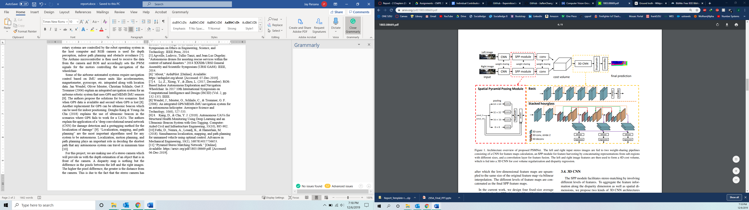

Figure PSMNet Architecture

The above architecture is obtained from [11, Fig. 1]. “The left and right input stereo images are fed to two weight-sharing pipelines consisting of a CNN for feature maps calculation, an SPP module for feature harvesting by concatenating representations from sub-regions with different sizes, and a convolution layer for feature fusion. The left and right image features are then used to form a 4D cost volume, which is fed into a 3D CNN for cost volume regularization and disparity regression.” [11]. For the KITTI 2012 dataset, the PSMNet gave an error of just 1.89% for the three-pixel-error which is outstanding [11]. Similar accurate readings were obtained from KITTI 2015 and Sceneflow dataset. Thus, we can implement this architecture on our stereo camera for getting an accurate depth of an object.

We are making use of Pixhawk 4 which is an open-source hardware design and it is an advanced autopilot system. It has an STM32F765 processor as its main FMU processor. It has four onboard sensors - Accelerometer/Gyroscope ICM-20689 for motion tracking of system, Accelerometer/Gyroscope BMI055, Magnetometer IST8310, and Barometer MS5611.

NuttX is a Real-Time Operating System (RTOS) developed for 8-bit to 32-bit microcontrollers that are used by Pixhawk. Its design is primarily based on POSIX and ANSI standards, but it includes some of the functionalities of UNIX standards. The main features of NuttX OS are as below.

* POSIX/ANSI-like task controls, named message queues, counting semaphores, clocks/timers, signals, threads, robust mutexes, cancellation points, environment variables, filesystem.
* Realtime, deterministic, with support for priority inheritance.
* System logging.
* Realtime, deterministic, with support for priority inheritance.

# Project Architecture

## Hardware Aspects

1. Drone Assembly

We have used DJI F450 Quadcopter X frame for this project. We are using Emax MT2213-935KV brushless motor which supports 20A – 30A ESCs, LittleBee BLHeil_s 30A ESC which supports 2-6s betteries. For autopilot system, we are using Pixhawk 4 mini open source autopilot hardware which uses NuttX OS and PX4 or Ardupilot autopilot firmware. For live location of drone we are using ublox GPS which comes with Pixhawk 4 mini. To control the drone remotely, we are using FrSky taranis Q X7 radio transmitter and x8r receiver at dorne side. For high-level architecture, we are using NVIDIA Jetson nano and Zed camera for object avoidance. We have 3D printed support for jestson nano. Two different betteries are required to power Pixhawk 4 min and jetson nano. One bettery is powering all ESCs, GPS and Pixhawk 4 mini through PM06 V2 power management module.

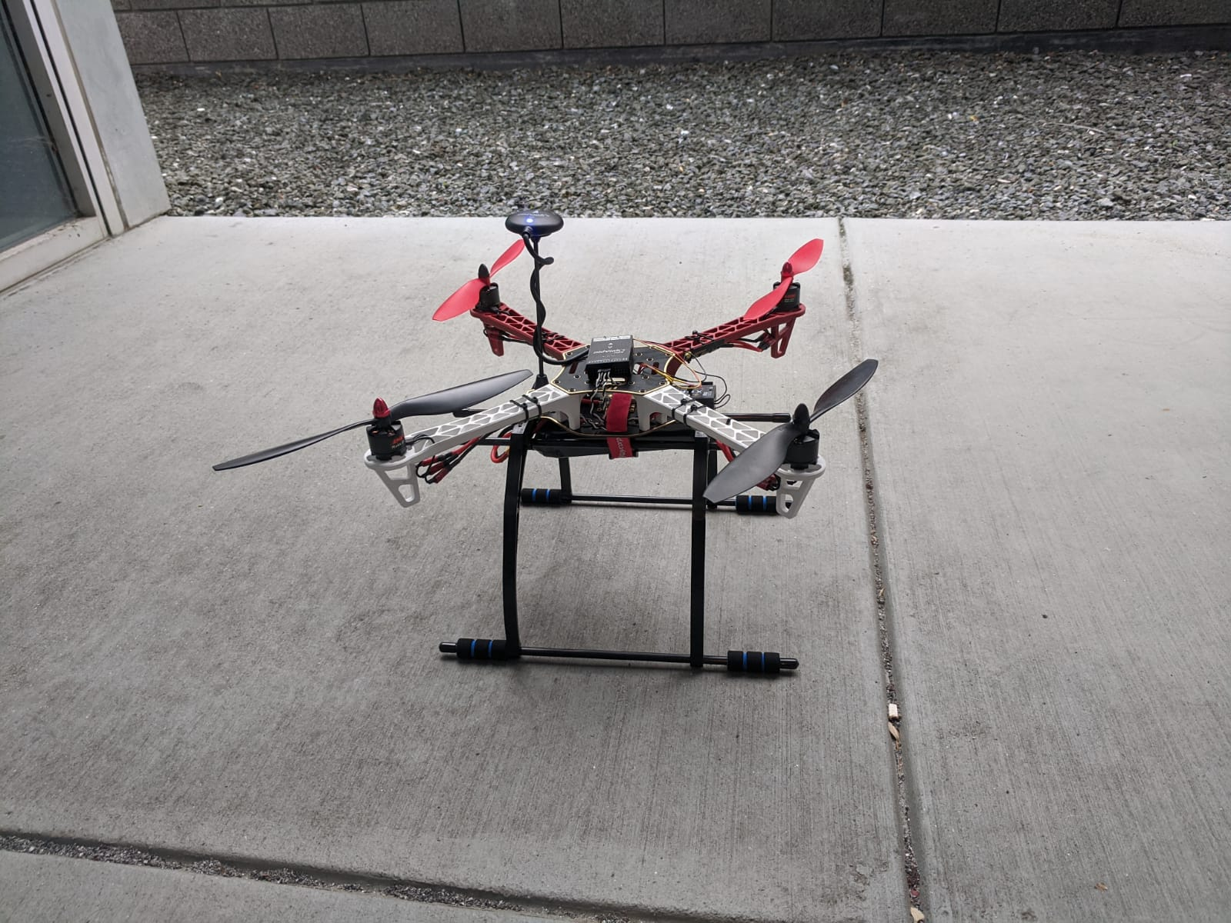

Figure DJI F450 Quadcopter

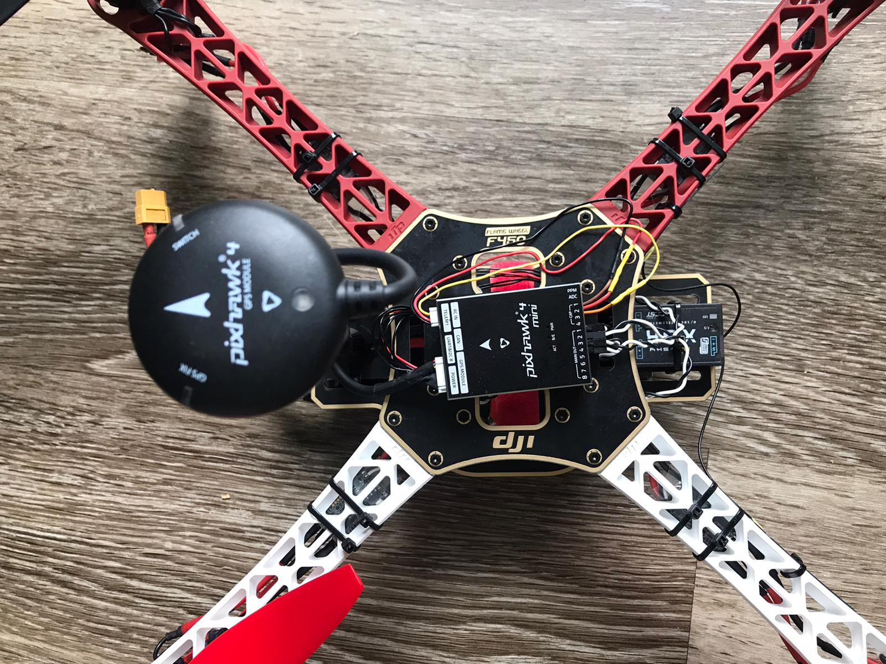

Figure Pixhawk4 and GPS at the heart of the quadcopter

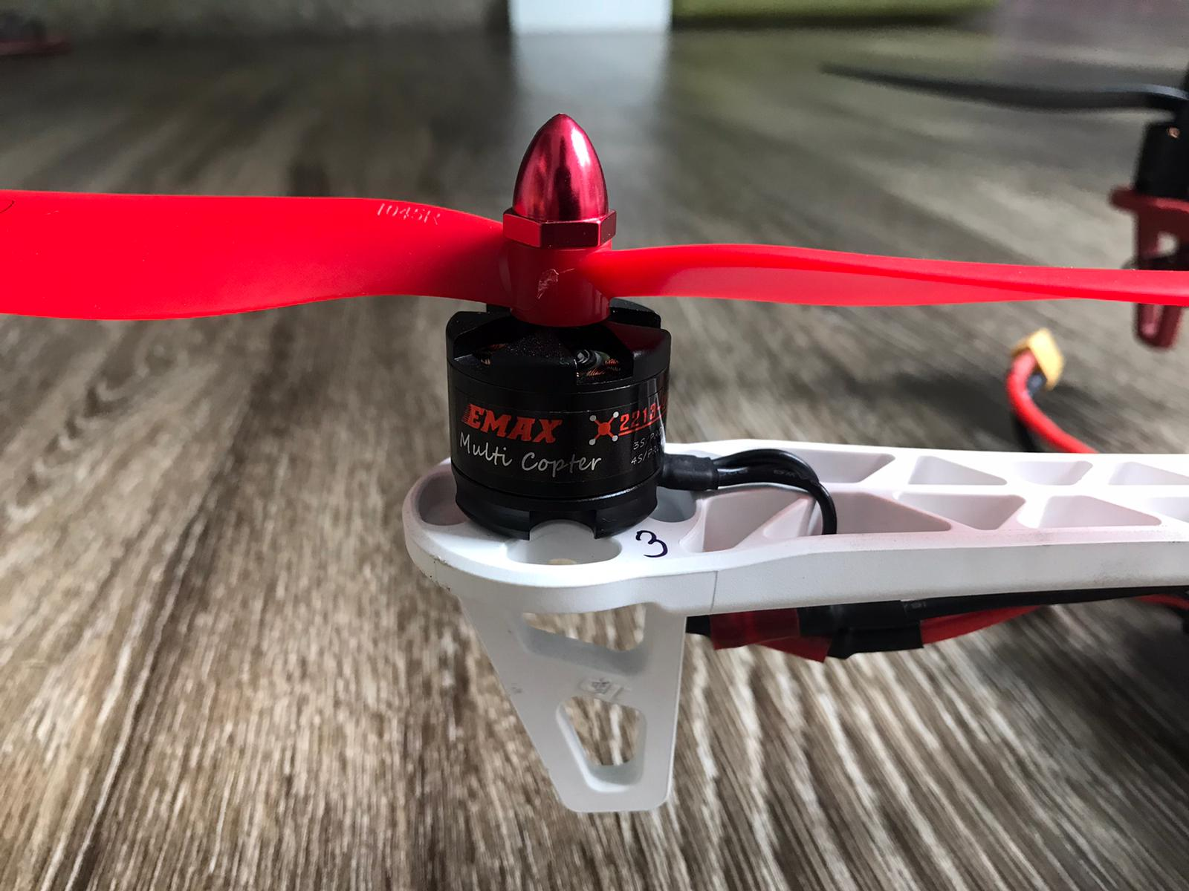

Figure Propellers connected to motors

1. 3-D mounts

## Software Aspects

# Methods / System Design

## System Block Diagram

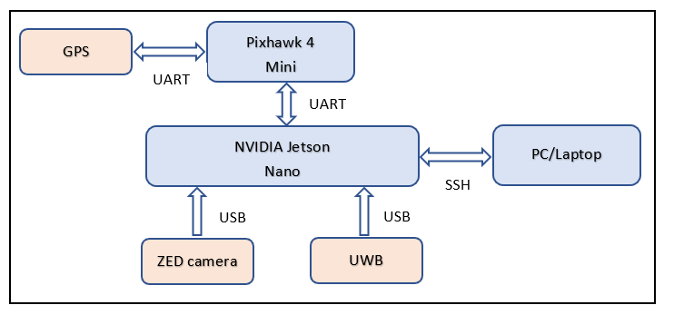

Figure System Block Diagram

The system is divided in two parts, low level software and High level software part. Pixhawk 4 mini in which PX4 firmware is running and GPS are the part of low level software. Low level is used for autopilot. Rest of the components of design is consider as high level which includes NVIDIA Jetson nano, ZED Camera and UWB. High level is used for object detection and localization. Here, ZED camera is used to measure depth perception and object detection. Jetson nano is running RTOS on it and trained machine learning model to detect objects. UWB is used for localization so that we can fly drone indoor without GPS. We can control our Jetson nano wirelessly from our PC/Laptop to send command like Take off, Landing and ARM and Disarm.

*B. Communication Infrastructure*

Communication between PC and NVIDIA Jetson nano is done by creating Access Point from jetson nano and connectiong our PC to nano through SSH.

Jetson nano is connected to the Pixhawk 4 mini physically through UART pins. To send command from nano to PX4 firmware we need to establish link between them as PX4 firmware is a Publisher and Subscriber type service. Due to which, when we send command to Pixhawk 4 mini from nano we need to subscribe to the specific service. MAVLINK makes this easy for us and do all internally. As we are using ROS in jetson nano, we have used MAVROS protocol which basically converts commands to MAVLINK internally. Steps to set up MAVROS link between nano and Pixhawk 4 mini are as follow.

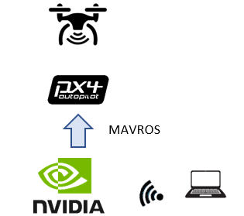

Figure High level system flow diagram

* + 1. Initialize an empty workspace.  
       mkdir -p ~/mavros_ws/src
    2. Follow instructions from PX4 Developers website for
    3. MAVROS installation Source Installation.
    4. Use catkin tools to build packages as opposed to catkin_make. catkin tools have better User Interface for Debug and Error messages while building.
    5. After building, find launch files to establish communication with Flight Controller over UART.
    6. For ArduPilot Stack use apm.launch file with fcu_url parameter. UART dev for TX2 is /dev/ttyTHSx  
       apm.launch fcu_url:=/dev/ttyTHS1

## Positioning and Localization

The positioning and localization for the connected and autonomous drone was achieved with the help of a ultrawide band beacon(UWB). One of the important application of using UWB technology is a RTLS network. RTLS stands for “Real time locating systems” which acts a localization mechanism for indoor conditions or at the confines spaces like co-orporate offices, airports, shopping malls, etc. Some of the advantages of using a UWB is mentioned below.

*Advantages:*

* In case of indoor positioning and to deploy a RTLS functionality, we cannot rely on GPS since its signal becomes weak inside the confined spaces. UWB can help combat the problem.
* Bluetooth and Wifi have higher ranges, but they are prone to noise and multipath propagation. UWB is immune to multipath propagation and noise.
* “High precision and less to no interference from other RFID, BLE or Wifi devices”[16]
* Power efficient transceivers

One of the common UWB modules used in the industry is MDEK1001 Development kit by Decawave. The MDEK 1001 is a development kit for creating a small scale RTLS network with the help of 12 packed DWM 1001 UWB modules. Some of the main components of DWM1001 are shown in Figure 7. DWM 1001 consists of few LEDs that indicate the communication status, battery status indication. LEDs D9-D12 are applicable when we use PANS firmware. The LED functionalities are mentioned in Figure 8.

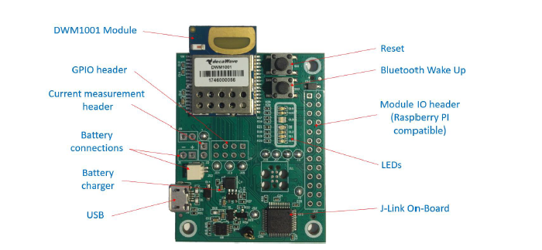

Figure DWM1001 module

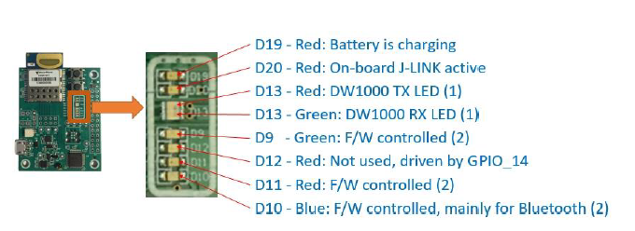

Figure DWM1001 LEDs

“The DWM1001 module is based on ultra-wideband transceiver IC DW1000, which is based on IEEE 802.15.4 standard. It integrates UWB and Bluetooth to provide RTLS functionality and networking which are controlled using APIs. The firmware architecture packed in the DWM1001 module provides two functions: the PANS API and the PANS library. The PANS API includes the Generic API which includes different API sets for different peripheral interfaces which acts as a translator between the protocols like UART, SPI and BLE, and the actual PANS library.Figure 9 shows the architecture of the DWM1001 firmware.”[17]

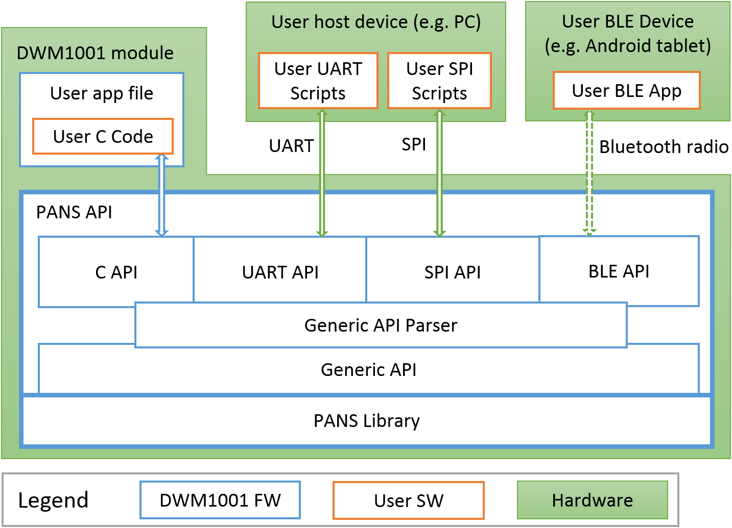

Figure High-Level Architecture of DWM1001 Firmware

For the scope of our project, we shall be using 2 methods to evaluate the UWB data. The first method is through an android application and the second method is directly using the DWM1001’s UART Shell Mode. The UART Shell mode elaborates about how the DWM1001 module communicates with the Jetson Nano via UART(USB) as shown in Figure 5. The evaluation methods are explained in section VI (Evaluation Methodology).

## Object Detection

Object Detection is an integral part of our project. It enables the drone to detect obstacles in its path in real-time and avoid crashing into it enabling autonomous operation. Object detection finds where in the frame various objects are located by extracting their bounding boxes. These bounding boxes indicate the objects in front of the drones which act obstacles in the pre-determined path of the drone.

Jetson Nano and TensorRT

The Jetson Nano Developer Kit has a Quad-core ARM A57 1.43 GHz and 128-core Maxwell architecture GPU. Nvidia provides its JetPack SDK which contains Linux OS and environments to build AI applications. The SDK supports NVIDIA TensorRT which enables high-performance deep learning inference. Application using TensorRT accelerates its performance by 40 times faster than CPU when real-time inference takes place. This allows optimizing Convolution Neural Nets (CNN) using many different deep learning frameworks, which can then be deployed to resource constraint embedded devices. TensorRT makes use of Nvidia’s CUDA platform to improve the inference for all major deep learning platform.[20]

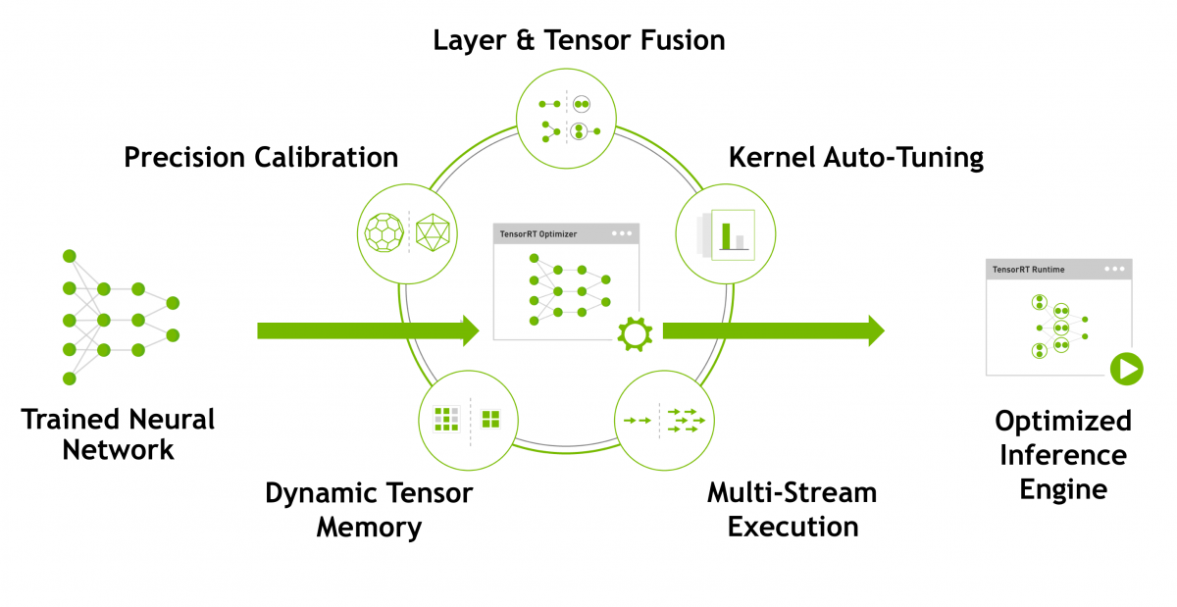

Figure 9. Nvidia TensorRT.

TensorRT scales down and quantizes the network parameter from FLOAT32 to INT8 and INT16 which reduces application latency required for many real-time embedded projects.

Model Selection for Object Detection

The main requirement for selecting a model for object detection for speed and accuracy. The model to be selected should have minimum latency since object detection and avoidance should have to performed in real-time. The model should also be accurate enough to make the correct object detection. Unfortunately, the Jetson Nano development board has limited resources and computation power. Thus, which selecting the model for object detection a tradeoff had to be made between speed and accuracy of the model. The model under consideration for selection are SSD-Mobilenet-v2 and Yolov3 which are optimized using Nvidia’s TensorRT. After evaluating the performance of both models, we came to the conclusion that SSD-Mobilenet-v2 is more accurate but slower than Yolov3 model. Since accuracy is a priority for object detection, we decided to use SSD-Mobilenet-v2 model for object detection in our application. The model is trained using MS COCO dataset which contains 330,000 images of 91 different classes such a person, chairs, cars, planes, water bottles, laptop, desk etc.

## Depth Sensing

The ZED camera is a stereo camera i.e. it has two cameras separated by a certain distance called the baseline. Due to this, the camera seems to mimic the human eyes which can perceive depth because of the distance between them. If the baseline is small, the depth perception for objects close to the camera would be excellent, but it would be inaccurate for faraway objects. If we keep on increasing the baseline, we could accurately measure the length of the faraway objects (given a camera with good quality image capturing ability) but the minimum distance for capturing the depth information would increase. This happens because the left and right images will capture an object at different positions due to the baseline separation i.e. there would be a shift in pixels. The depth is inversely proportional to the shift in the pixels. Thus, closer objects would appear more shifted and the faraway objects would appear less shifted between the left and right images as shown below:

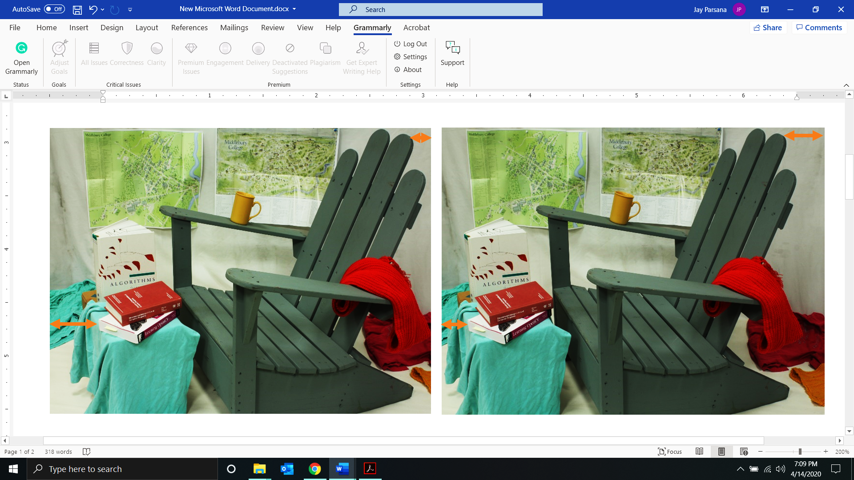

Fig. 2 Left and right images with the pixel shift

The ZED camera SDK has many API’s in python and C++ to control the camera and get the depth and point cloud. We make use of the python for building our application. It uses the above-discussed techniques to obtain the depth information in an image. We make use of the ZED SDK as it utilizes CUDA and Nvidia GPU to parallelize the processes like block matching, getting depth map from disparity, etc.

We use the camera in 720p mode with a maximum FPS of 30 so that we can add the object detection model and obtain a good FPS overall. The setting should be on AUTO mode. There are three depth modes ULTRA, QUALITY, and PERFORMANCE and we make use of the PERFORMANCE mode for faster execution. For getting the depth map we use the left image as the reference. After retrieving the depth mode, we construct the 3D point cloud. This helps us to get the distance to a pixel by using the euclidean distance formula:

$${distance}_{(x,y)}= \sqrt{x^{2}+y^{2}+z^{2}}$$

where,

Z: Depth at point (x, y)

The steps to be followed for getting the distance is as follows:

1. Create a ZED camera object and set all the required parameters as stated above.
2. Use the while loop to get to the images one by one. Check if the camera has a new image and grab the left image.
3. Convert the ZED image matrix to the CUDA capsule matrix.
4. Feed this capsule to the object detection model and acquire the detections from the model which includes information such as object classification, bounding boxes, and confidence.
5. Use the jetson utilities to grab the center point of each bounding box i.e. the detected object and extract its (x, y) coordinates.
6. This (x, y) coordinates are used as a parameter to grab the z co-ordinate from the point cloud.
7. The next step is to use the (x, y, z) coordinates into the Euclidean formula to obtain the distance at (x, y).
8. Repeat steps 6-7 to obtain the distance for all the objects.
9. Pass this data to the low-level system to avoid the obstacles.

# Evaluation Methodology

## UWB Localization

The ultra wideband beacon DWM1001 can be configured into various modes such as tag, anchor, listerner as mentioned in reference [18].

*Preparation of Anchors:*

* Anchors are the unit that placed as a reference points at various locations in the indoor conditions.
* Mount the anchors at the high level and within the line of sight as mentioned in the Figure 10.
* Minimum 3 anchor units are required to establish an RTLS connection.
* Power them using batteries or a power bank or a USB power adapter directly plugged to supply.

*Preparation of Tag:*

* Tag is a main unit deployed on the device whose location needs to be tracked in the inner conditions.
* Minimum 1 tag unit is required to establish a connection. Powering it is similar to anchor.

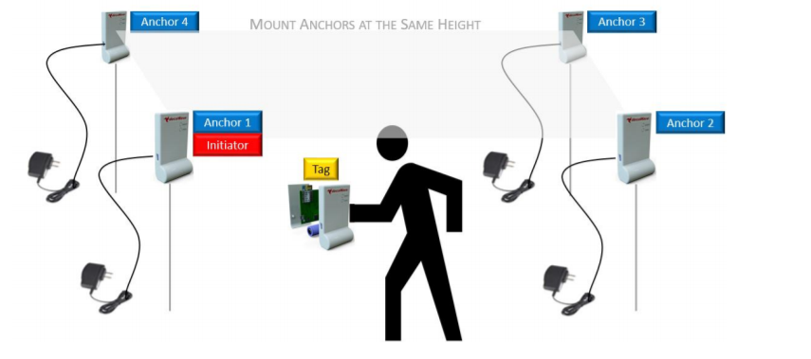

Figure Positioning the tags and anchors

***First Approach- Andriod Application:***

Few modules may act as anchors and one module can act as a tag which is attached along with a robotic system or a unit whose position needs to be monitored in the indoor conditions. The anchors and tag communicate with each other via UWB. There is an android application that controls and configures these sensors over BLE. This application shall be used to monitor the relative distance between the tag and the anchors to pin-point the exact coordinates of the tag. Here are the **evaluation steps** that was performed using the android application:

1. Mount at least 4 anchors on the wall as per the positioning mentioned in the instruction manual and assign remainder as the tags whose location needs to be monitored.
2. Start the device discovery and perform the configuration
3. Auto position these units and measure their distances with respect to the initiator.
4. Upload the floor plan, modify the units and change the refresh rate using the android app and repeat the above steps to measure the sensor performance.

Detailed description of using an andrioid app is as follows:

* Download the Decawave RTLS Manager apk file from the decawave’s website: https://www.decawave.com/product/mdek1001-deployment-kit/
* Power on all the modules at their factory settings and start the device discovery in app’s home screen
* The devices will be detected as tags and devices will be grouped as unassigned device, unassigned networks and networks as shown below. Select the devices and provide a network name and assign all the unassigned devices to these networks:

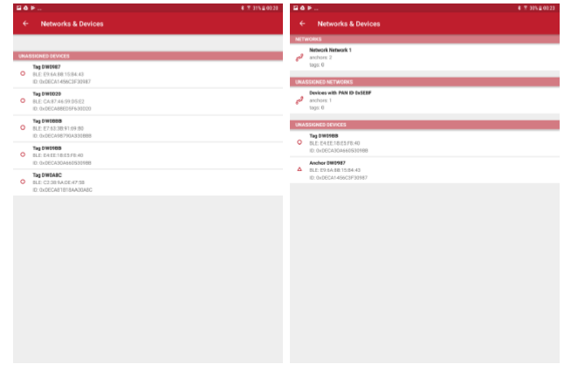

Figure Devices detected as unassigned devices and unassigned networks

* The configuration of the anchor needs to be done as mentioned in figure 8 by clicking on the edit section. Select one of the anchors as an initiator and keep the value of x,y,z as (0,0,0). Ensure UWB is active.
* The configuration of the tag needs to be done as mentioned in figure 8 by clicking the edit button. Make sure the UWB and BLE is active.

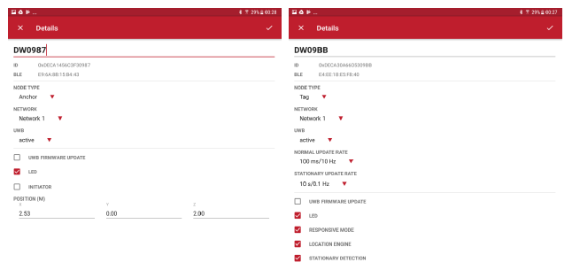

Figure Configuring tags and anchors

* Once the tags and anchors are configured, select the autopositioning feature and follow the steps in page 27[18] on how to reorder the anchor sequence.

***Second Approach- UART Shell mode:***

We connect the DWM1001 module, which needs to be configured as tag and placed in the quadcopter to monitor its location in indoor environment, to the Jetson Nano via USB connection. Below is the step-by-step evalutation method in Jetson Nano’s Ubuntu 18.04.

* Go to the website: <https://www.segger.com/downloads/jlink/#J-LinkSoftwareAndDocumentationPack> and download the J-Link Software and Documentation Pack for LINUX ARM systems.
* Once downloaded, extract it using tar -xvzf and install the USB driver as mentioned in README.md file.
* After installing the driver and restarting the Nano, we will be able to see the SEGGER device at /dev/ttyACM0 using the command in below figure.

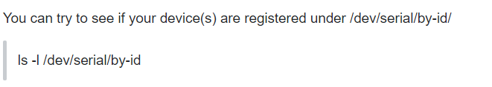

* Since the devices come with the factory settings, we go ahead and enter the shell mode by pressing “Enter key” twice.
* We connect the anchors to the Jetson Nano and configure them in Shell mode[19].
* The first Anchor needs to configured as an initiator which can be achieved using the below commands

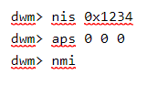

* “nis” sets up the PAN id to 0x1234, “aps” sets the initiator position to x=0,y=0,z=0, “nmi” configures the node as initiator and resets the device.
* Remaining anchors can be initiated directly in shell mode using the below commands.

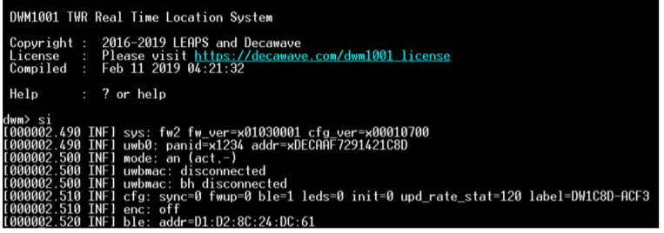

Figure Anchor configuration in shell mode

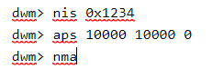

* “nma” configures the node as normal anchor and “aps” set the distance as x=10000, y=10000, z=0(mm).
* Similarly, tag can be configured in shell mode using the below commands.

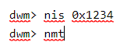

* “nmt” sets the node as tag and resets the device and “si”provides the node status as shown in Figure 13.
* After the nodes are configured, the system looks like the image as follows:

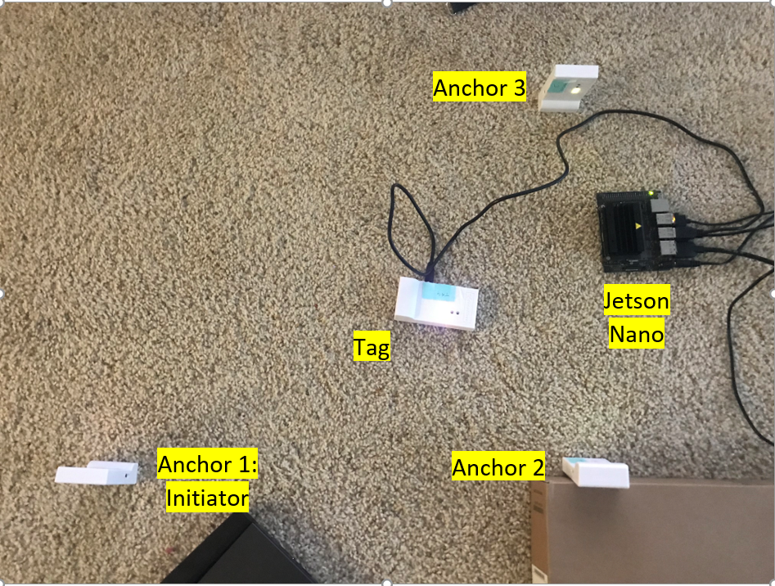

Figure DWM1001 tag with Jetson Nano and anchors

## Obstacle Detection using Camera

To evaluate the object detection model on the Jetson Nano initially a pre-trained SSD-Mobilenet-v2 is passed an input image consisting of multiple persons.

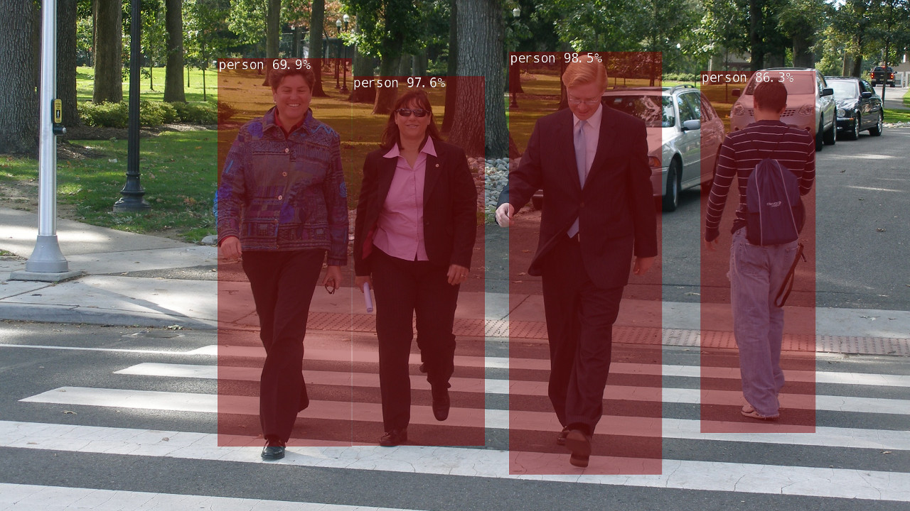

Figure 5. Object Detection

Once the pre-trained object detection model is tested against sample input images, an application of object detection for drone is created by inferencing on real-time captured images.

Algorithm for developing Object detection model is as follows:

1. Python packages ‘jetson.inference’ and ‘jetsons.utils’ is imported which contains class for object detection and camera capture.
2. The appropriate object detection network is loaded i.e. the 91-class SSD-Mobilenet-v2. Classification threshold of 0.5 is set.
3. The camera stream object is created for the attached ZED Camera via USB.
4. An OpenGL display loop is created to view the captured video frames in real-time.
5. The images is captured from the camera, and passed on the Object detection network.
6. The detections obtained can be printed out and also displayed to the user with bounding boxes and labels in real-time.
7. Step E and F is repeated continuously to perform real-time object detection until the user quits.

## Depth sensing using Camera

We made use of the ZED camera to capture the depth of the obstacles which are in the front of the drone. First, the obstacle detection model was run on the image obtained from the ZED. Based on the objects detected, we retrieve the depth on that object. The output of the code is shown in Fig. 4 which shows the objects, their name and the distance to the object from the camera.

We measured the objects physically using the measuring tape. The distances from the camera to the object detected in the image were accurate up to 98%. The frame rate that we obtained for the entire process after object detection and distance measurement was 10FPS.

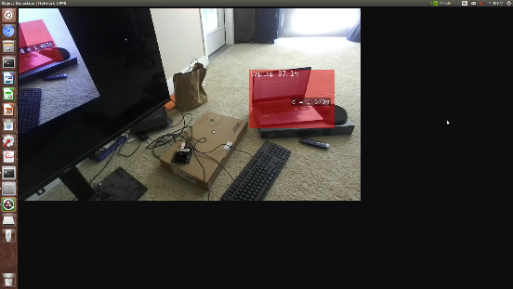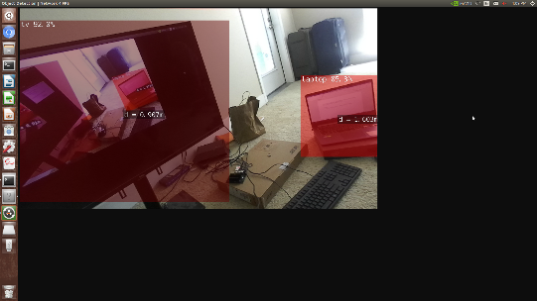

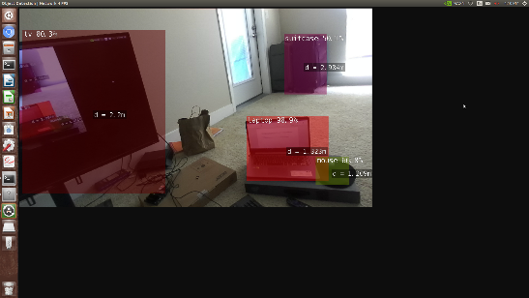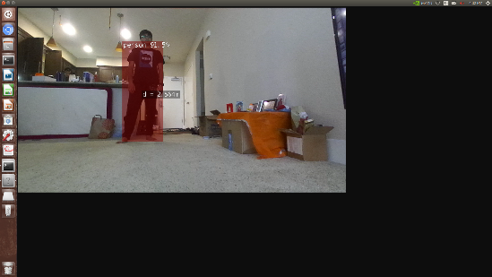

Fig. 4 Images with objects detected and their distances (in meters) from the camera displayed

## Automatic Landing using ground detection

# Results

## UWB Localization

When we configured all the DWM1001 nodes with android app, we were able to see the relative distance between tag and other anchors in Grid View as mentioned below

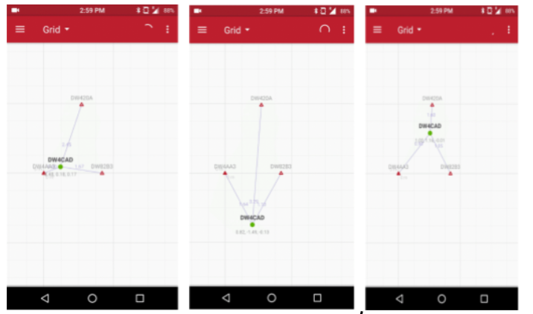

Figure DWM1001 localization using Android App

The accuracy of the DWM1001 distances measured relative to the anchors in the android application was nearly around 10cm. We can see the position log file in the menu bar and save it as a .txt file.

When the DWM1001 was configured in shell mode using Jetson Nano, we achieved the range of 5 to 6m. Below figure shows the relative distance between all the anchors and tag by running the “les”command in the shell mode.

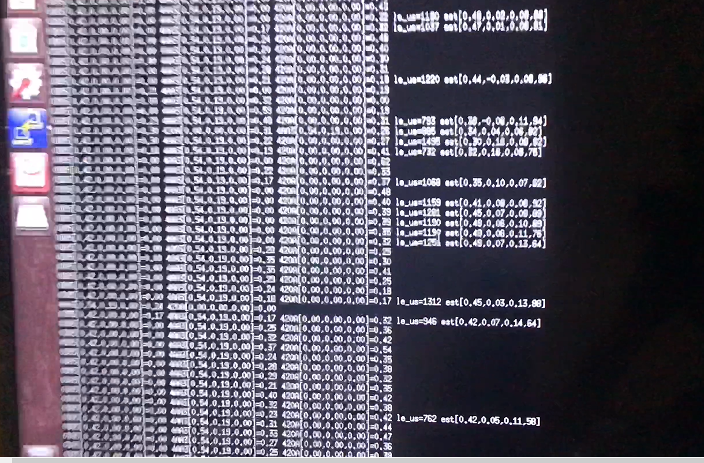

Figure Logging distance information between Tag and anchors in Jetson Nano Ubuntu 18.04

# References

[1] Kara, D. (2004). Sizing and seizing the robotics opportunity, RoboNexus. This text can be accessed online at Robotics Trends Inc. http://www.roboticsevents.com/ robonexus2004/roboticsmarket.html Accessed 12.06.19

[2] Koh, Lian Pin, and Serge A. Wich. "Dawn of drone ecology: low-cost autonomous aerial vehicles for conservation." Tropical Conservation Science 5.2 (2012): 121-132.

[3] Erdelj, Milan, Michał Król, and Enrico Natalizio. "Wireless sensor networks and multi-UAV systems for natural disaster management." Computer Networks 124 (2017): 72-86.

[4] Wilson, Richard L. "Ethical issues with use of drone aircraft." Proceedings of the IEEE 2014 International Symposium on Ethics in Engineering, Science, and Technology. IEEE Press, 2014.

[5] Apvrille, Ludovic, Tullio Tanzi, and Jean-Luc Dugelay. "Autonomous drones for assisting rescue services within the context of natural disasters." 2014 XXXIth URSI General Assembly and Scientific Symposium (URSI GASS). IEEE, 2014.

[6] “About,” ArduPilot. [Online]. Available: https://ardupilot.org/about. [Accessed: 07-Dec-2019].

[7] 4. Li, Z., Xiong, Y., & Zhou, L. (2017, December). ROS-Based Indoor Autonomous Exploration and Navigation Wheelchair. In 2017 10th International Symposium on Computational Intelligence and Design (ISCID) (Vol. 2, pp. 132-135). IEEE.

[8] Wendel, J., Meister, O., Schlaile, C., & Trommer, G. F. (2006). An integrated GPS/MEMS-IMU navigation system for an autonomous helicopter. Aerospace Science and Technology, 10(6), 527-533.

[9] 8. Kang, D., & Cha, Y. J. (2018). Autonomous UAVs for Structural Health Monitoring Using Deep Learning and an Ultrasonic Beacon System with Geo‐Tagging. Computer‐Aided Civil and Infrastructure Engineering, 33(10), 885-902.

[10] Fethi, D., Nemra, A., Louadj, K., & Hamerlain, M. (2018). Simultaneous localization, mapping, and path planning for unmanned vehicle using optimal control. Advances in Mechanical Engineering, 10(1), 1687814017736653.

[11] “Pyramid Stereo Matching Network.” [Online]. Available: https://arxiv.org/pdf/1803.08669.pdf. [Accessed: 06-Dec-2019].

[12] Mai, Vincent, et al. "Local Positioning System Using UWB Range Measurements for an Unmanned Blimp." IEEE Robotics and Automation Letters 3.4 (2018): 2971-2978.

[13] Shi, Zhiyuan, et al. "A Nano-Quadcopter Formation Flight System Based on UWB Indoor Positioning Technology." 2018 13th International Conference on Computer Science & Education (ICCSE). IEEE, 2018.

[14] A. Rohan, M. Rabah, and S.-H. Kim, “Convolutional Neural Network-Based Real-Time Object Detection and Tracking for Parrot AR Drone 2,” IEEE Access, vol. 7, pp. 69575–69584, 2019.

[15] P. Chen, Y. Dang, R. Liang, W. Zhu, and X. He, “Real-Time Object Tracking on a Drone with Multi-Inertial Sensing Data,” IEEE Transactions on Intelligent Transportation Systems, vol. 19, no. 1, pp. 131–139, 2018.

[16] “Advantages of using Ultra Wideband (UWB) technology for Indoor Positioning”[Online]. Available: <https://hackernoon.com/https-medium-com-pathpartnertech-ultra-wideband-uwb-technology-for-indoor-positioning-a5fbe76d6a4c> [Accessed: 13-Apr-2020]

[17] “DWM1001 Firmware Guide v2.1”[Online]. Available: <https://www.decawave.com/wp-content/uploads/2019/01/DWM1001-Firmware-User-Guide-2.1.pdf> [Accessed: 13-Apr-2020]

[18] “MDEK1001 System User Manual”[Online]. Available: <https://www.decawave.com/sites/default/files/mdek1001_system_user_manual.pdf> [Accessed: 13-Apr-20]

[19] “DWM1001 Gateway Quick Deployment Guide”[Online]. Available: <https://www.decawave.com/wp-content/uploads/2019/03/DWM1001_Gateway_Quick_Deployment_Guide.pdf> [Accessed: 13-Apr-20]

[20] “NVIDIA TensorRT” [Online]. Available: <https://developer.nvidia.com/tensorrt> [Accessed: 17-Apr-20]

1.